Title: MTP Goals
Subject: MTP 9

1. Goals  A. Main goal: Price Stability  B. Secondary Goal: Maximum employment  2. CB Optimization process  3. Taylor Rule | Main: Price stability  Second-level: High employment, Economic growth  Third-level: Financial market stability, Interest rate stability, Foreign exchange stability  Hierarchical mandates have price stability as the primary goal of monetary policy (ex. BoE, ECB). However, “without prejudice to price stability CBs should support the general economic policies etc.” In the LR there is no conflict between price stability and other goals of monetary policy, in the SR there is a Trade-off. Solution: price stability is a LT goal, ECB has de facto room for a dual mandate, where some deviations in inflation are allowed to help the job market/econ output in the SR In practice no difference Dual vs Hierarchical mandates as long as price control is not a SR goal!  We want low and stable inflation, why?  Negative effects of inflation (inflation costs)  I. Shoe-leather cost (cost of long run average inflation)  Refers to the cost of time and effort that people spend trying to counter-act the effects of inflation, such as holding less cash and having to make additional trips to the bank (“more walking” is required to go to the bank ).  II. Distortion from un-indexed tax system  Due to unindexed progressive income taxes: when nominal income increases with inflation, people have to pay higher taxes even though real income stays the same  Due to tax on capital gains: when stock prices increase as with inflation, people have to pay taxes even if there is no real capital gains  III. Relative price dispersion due to price stickiness (cost of short run inflation fluctuations)  Only a fraction of firms change their prices each period. Some firms adjust faster some slower. The relative price dispersion is not caused by changes in preferences or technology (real value). Market value <> real value relative value is altered. Prices become bad allocation mechanism.  IV. Redistribution of wealth due to nominal debt contracts  Consequence of nominal debt contracts and inflation fluctuations. When inflation increases, debtors gain because real debt decreases and creditors lose market interest premia  V. Leads people to accumulate real goods (ex. gold)  less liquid resources to conduct economic activity (less money around)  VI. Time inconsistency problem (risk of discretionary monetary policy )  The temptation to abandon a beneficial LT plan for ST gains (parents give gifts to child to let them stop screaming in the SR, however this will make them scram even more in the LR). CBs could be pushed (ex. by political pressures) to pursue expansionary policy to bolster the economy in the SR this doesn not affect growth in the LR but raises inflation! Nominal anchor acts as a sort of moral rule, an expected constraint on CB behavior !  These costs are minimized when the inflation rate is equal to 0, but in practice many CBs target a positive (though low) rate of inflation, why?  Positive effects of inflation  I. Zero bound on nominal interest rates: r = i – π  We want some inflation buffer. Suppose we need to make expansionary monetary policy (decrease r). Nominal interest is at 0. Still we can decrease r by raising π  II. Upward bias in inflation measure  PC in 2011: 1000 euro, PC in 2012: 1040 euro --> Price raised by 4%, but quality is different  The quality adjusted rate of inflation is lower than 4%. Targeting 0 inflation may mean targeting deflation  III. Downward nominal wage rigidity  Lot of evidence of downward nominal wage rigidity. With inflation, then real wage can decrease without affecting nominal wage.  could 4% be better? maybe, but problem: credibility of CB  Unemployment causes poverty and misery + creates idle workers and idle resources (ex. empty plants)  We want full employment. But what is it? Not 0 unemployment = impossible. why?  There is frictional unemployment: it is good that firms and workers take some time to select the right matches  There is structural unemployment: mismatch between job requirements and the skills or availability of local workers. Undesirable, nut MP can’t do much. This goal for high employment is a level above zero, consistent with full employment. This level is called the natural rate of unemployment (NAIRU).  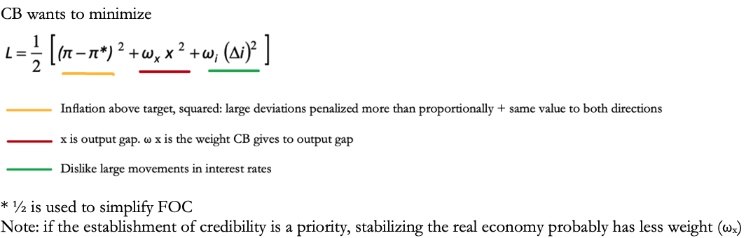  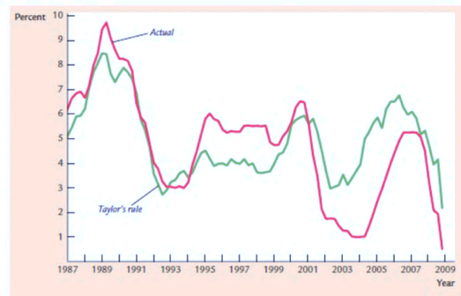  Interest rate target = πt + r^{e}(=2%) + ½ (Inflaiton gap) + ½ (output gap)  *inflation gap: current inflation – target inflation  Ex. inflation rate at 3%, leading to a positive inflation gap of 1%(target 2%), and real GDP is 1%. Then the Taylor rule suggests that the interest rate should be set at 6%.  Although the Fed does not explicitly follow the Taylor rule, this rule works well in describing how MP has been conducted in the past yrs.  The rule "recommends" a relatively high interest rate ("tight" monetary policy) when inflation is above target or when output gap is positive, and a relatively low interest rate ("easy" monetary policy) in opposite cases. Sometimes these goals conflict: inflation may be above target when output gap is negative; in such situations, the rule provides guidance to policy makers on how to balance these competing considerations when setting interest rates  Taylor principle: response to nominal rate is greater than increase in inflation. I.e. if the inflation rate rises by 1%, the interest rate target should be raised by 1.5%, and so by more than one-to-one.

